**GARAGE MANAGEMENT SYSTEM**

**COLLEGE NAME**: V.N. Krishnaswamy Naidu College of Arts and Science for Women

**COLLEGE CODE**: Bru4b

**TEAM ID**: NM2025TMID28290

**TEAM MEMBERS**:5

**Team Leader Name**: Beula. G

**Email**: [beula1462006@gmail.com](mailto:beula1462006@gmail.com)

**Team Member 1**: Nalene. S

**Email**: [nalenesathisnalene@gmail.com](mailto:nalenesathisnalene@gmail.com)

**Team Member** **2**: Aarthi. R

**Email**: [aarthiaarthi31748@gmail.com](mailto:aarthiaarthi31748@gmail.com)

**Team Member 3**: Dharshana. V

**Email**: [dharshanav786@gmail.com](mailto:dharshanav786@gmail.com)

**Team Member 4**: Shobika.K

**Email**: [shobikakumar70@gmail.com](mailto:shobikakumar70@gmail.com)

**INTRODUCTION:**

**Project Overview**

The Garage Management System (GMS) is a Salesforce-based application designed to manage customer vehicles, service requests, mechanics, billing, and inventory. The goal is to provide an efficient, cloud-based solution for automotive garages to streamline their operations and improve customer satisfication.

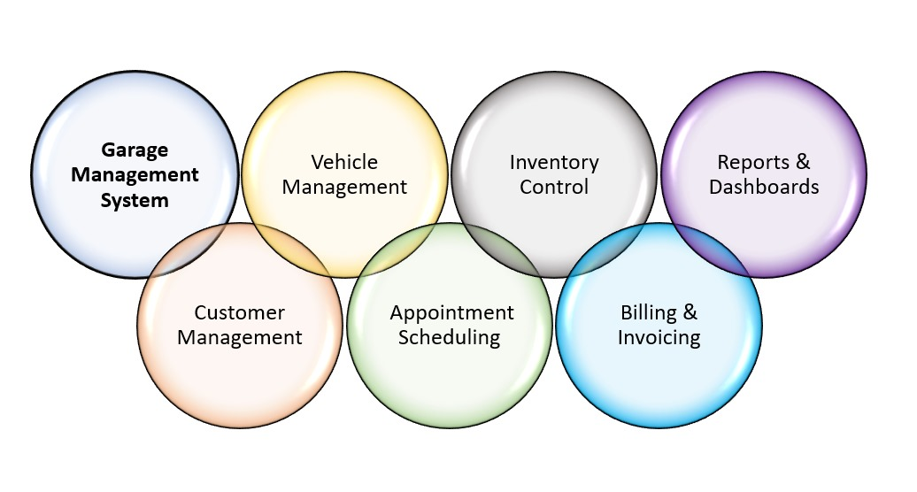

**Objectives**

The purpose of this project is to provide an end-to-end digital solution that manages all garage operations—from customer and vehicle information to service scheduling, inventory control, and billing—on the Salesforce cloud platform. By replacing manual processes with automated workflows and real-time dashboards, the system aims to improve efficiency, reduce errors, enhance customer satisfaction, and offer data-driven insights for better business decisions.

**Development Phase**

* *Creating developer account*

By using this URL - <https://developer.salesforce.com/signup>

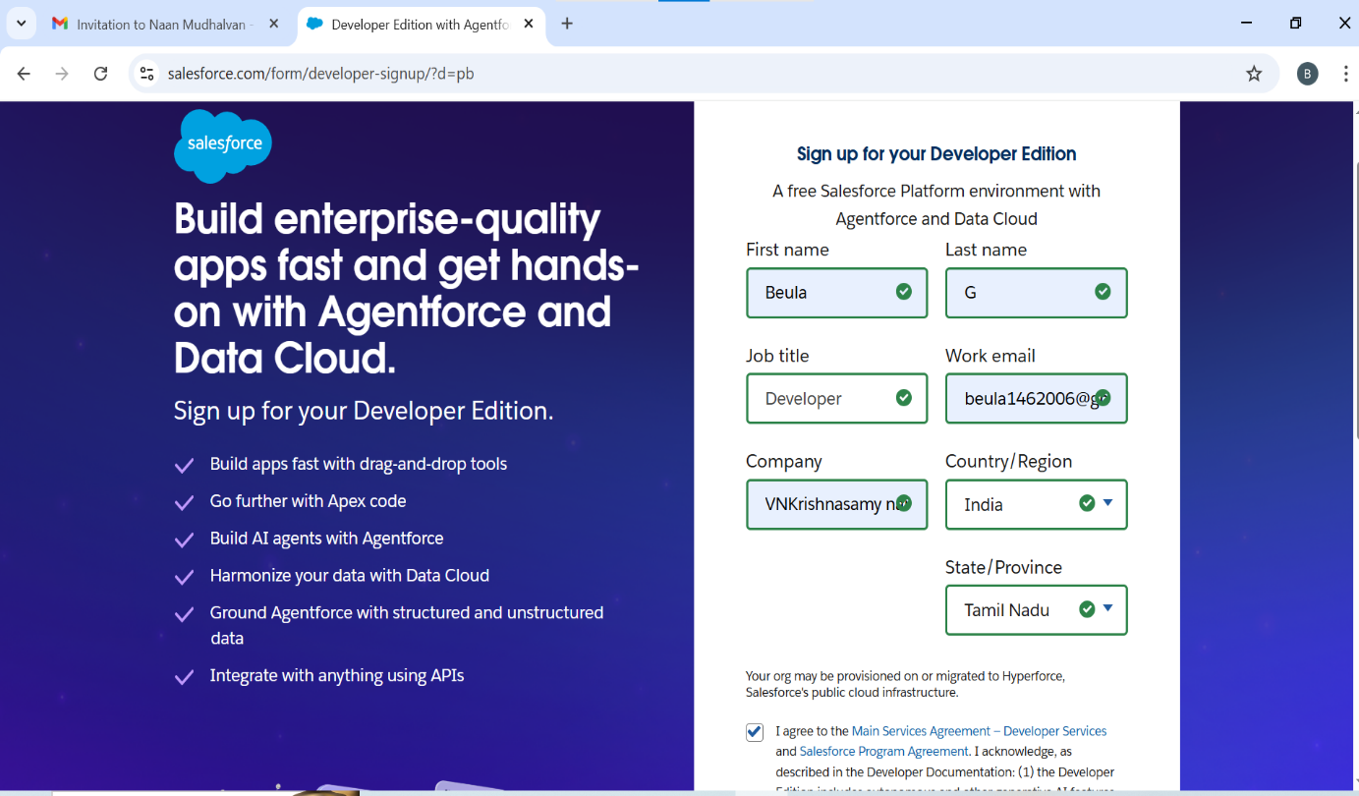

* *Click on verify account to activate your account*

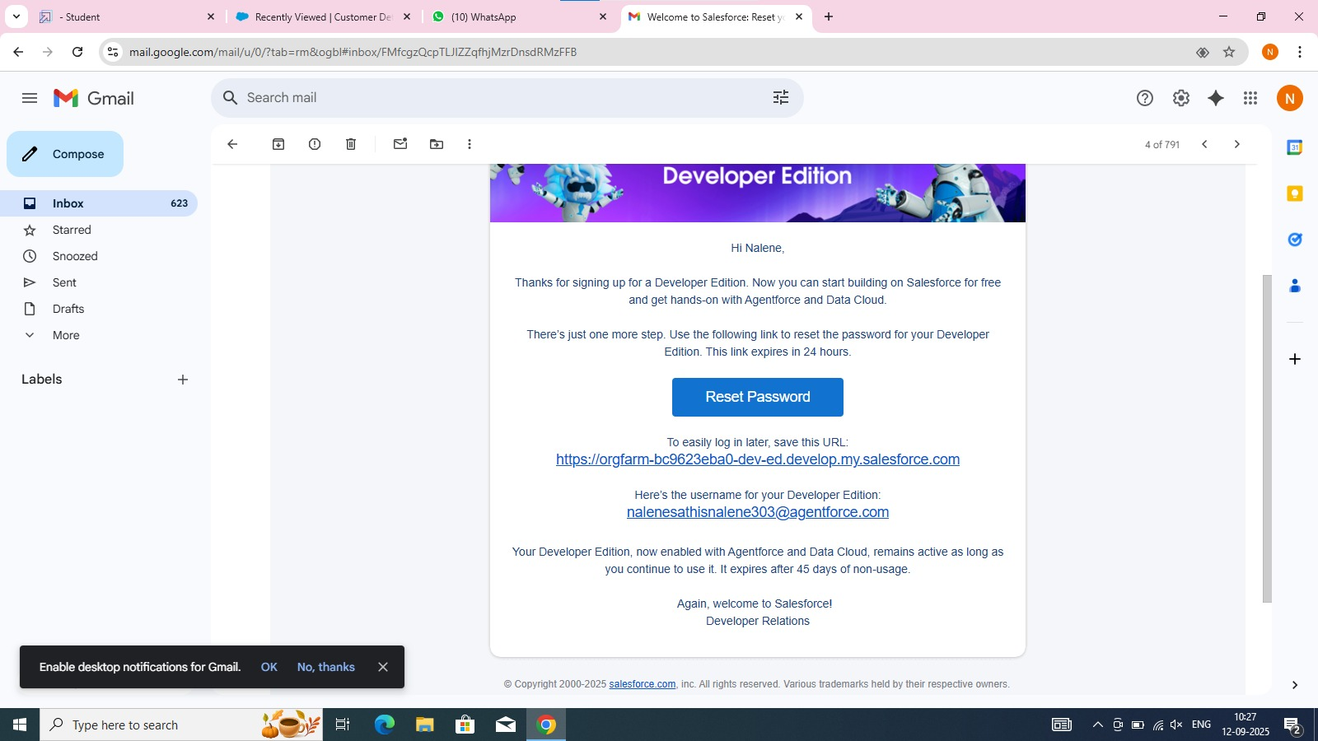

* *Create an Objects for customer details object, appointment* object*, services records, and billing details & feedback*

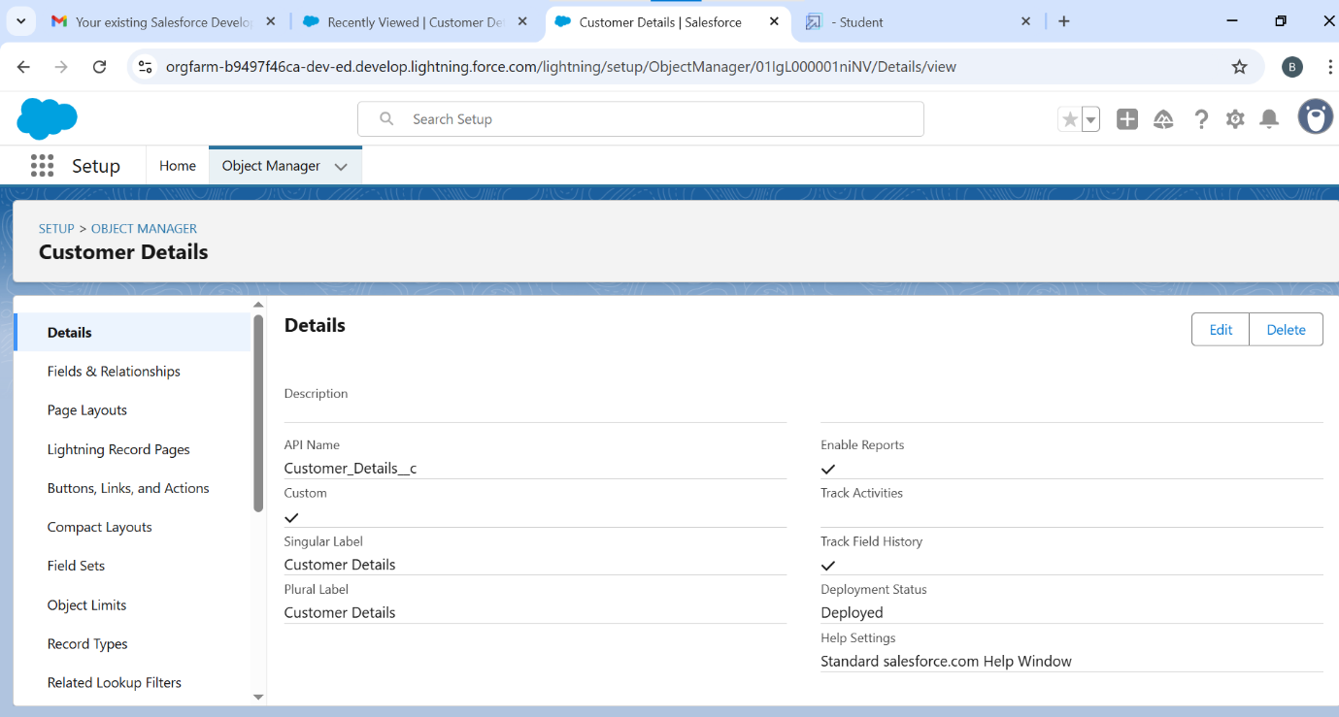

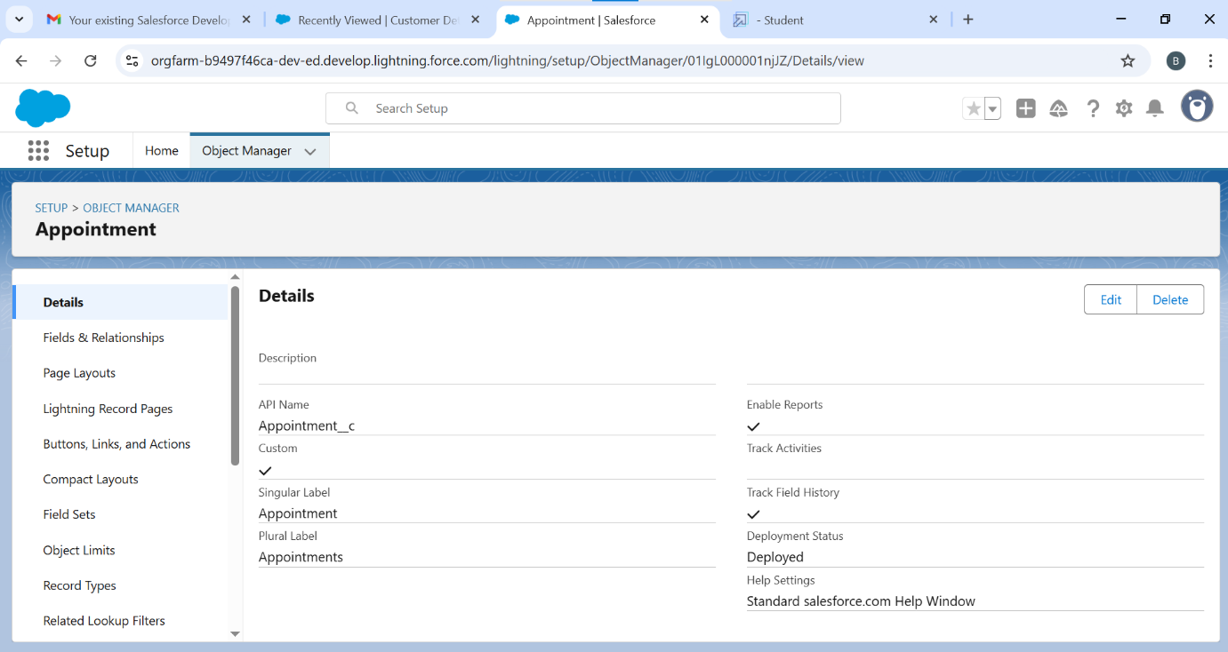

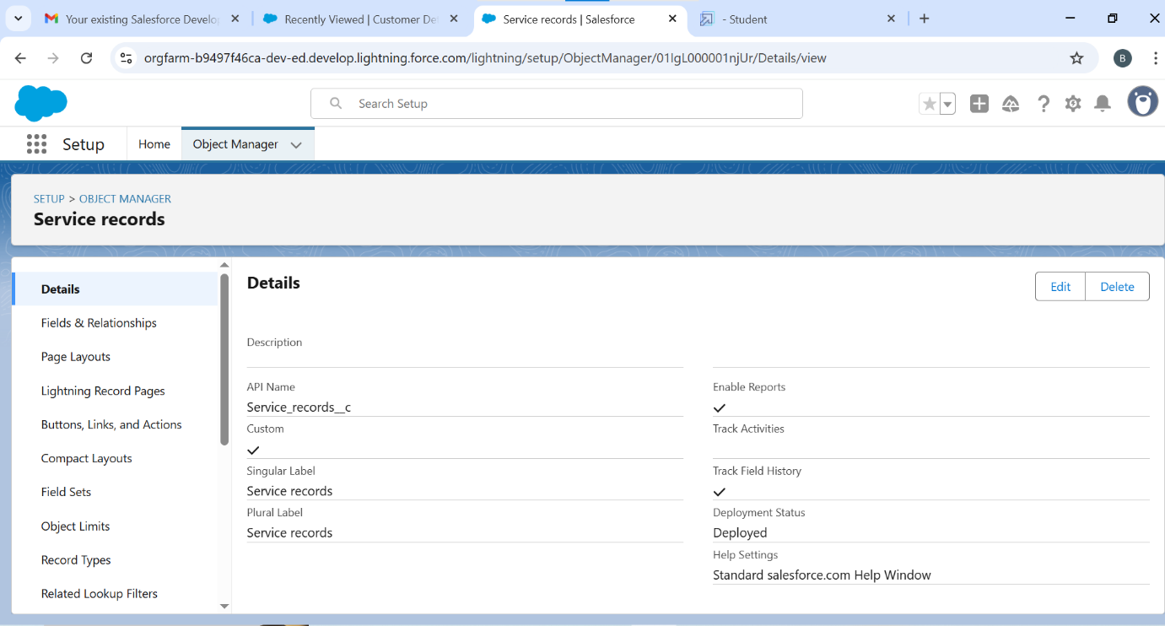

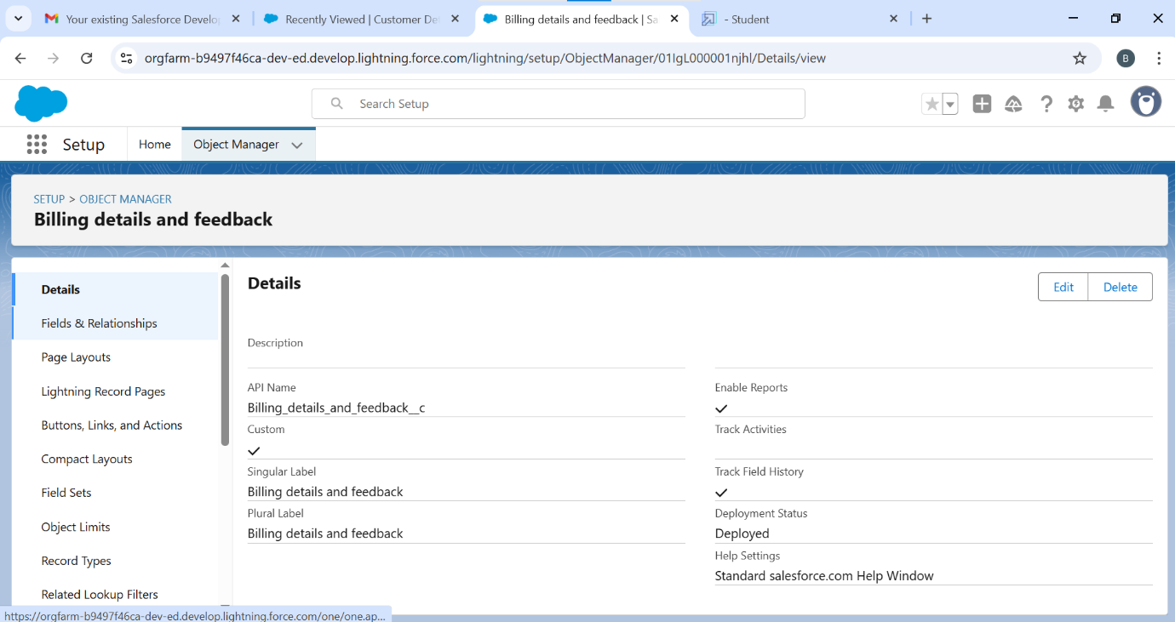

* *Create custom tabs and other for Quick access*

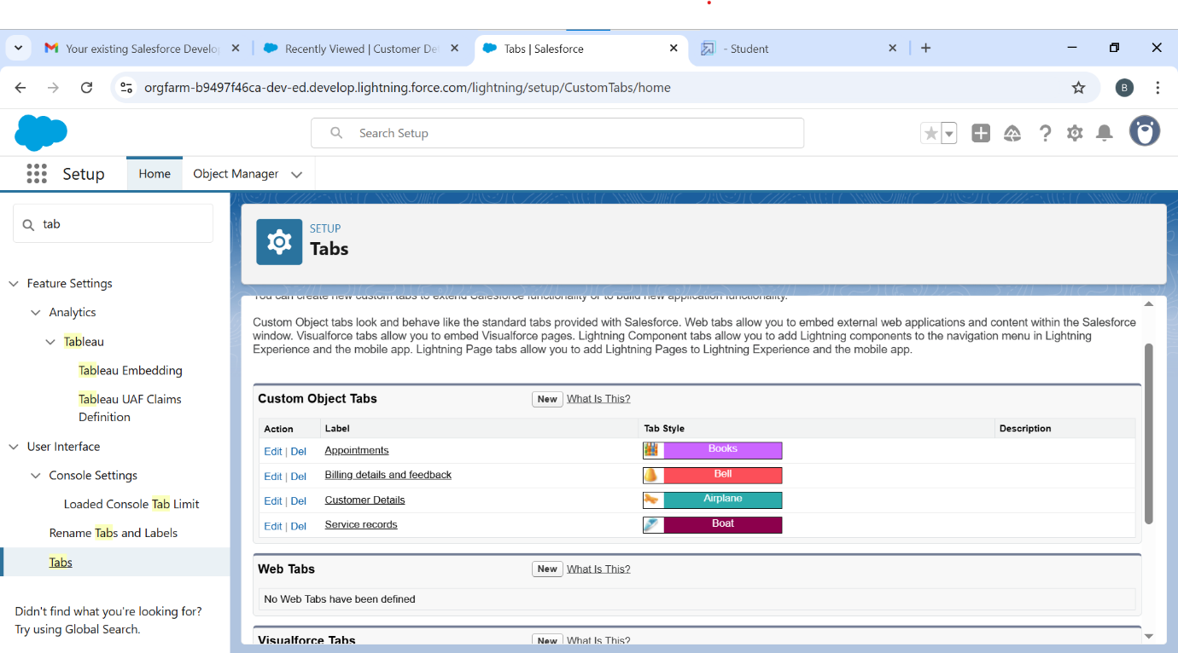

* *Lightning App to build everything together in one place*

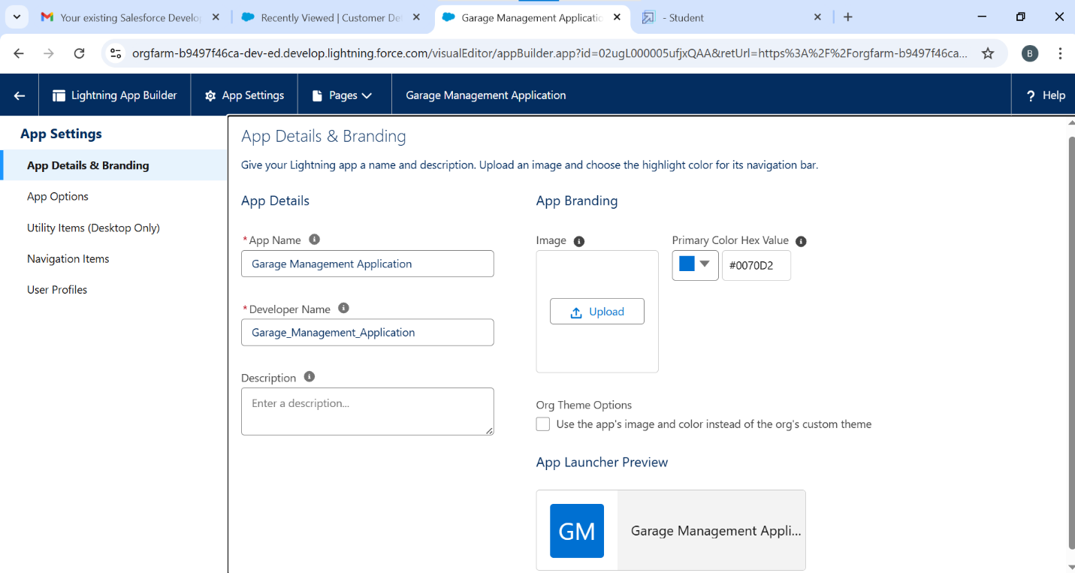

* *Fields to capture specific details like vehicle number, service type, service cost, and status*

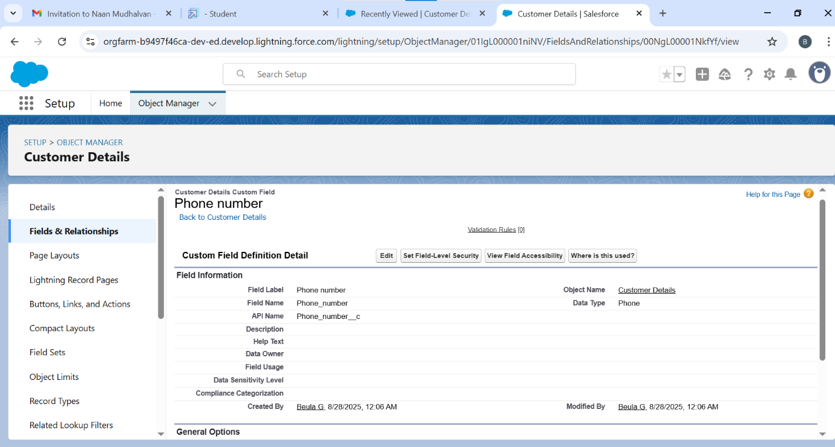

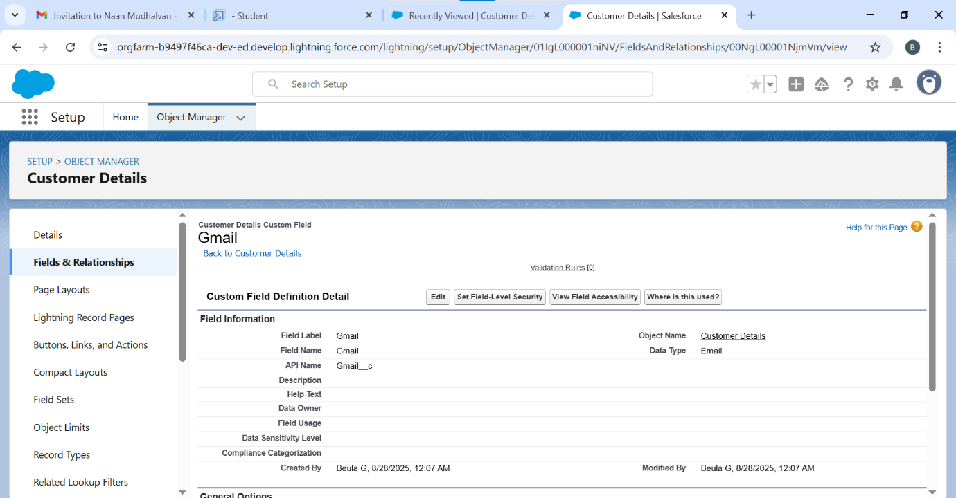

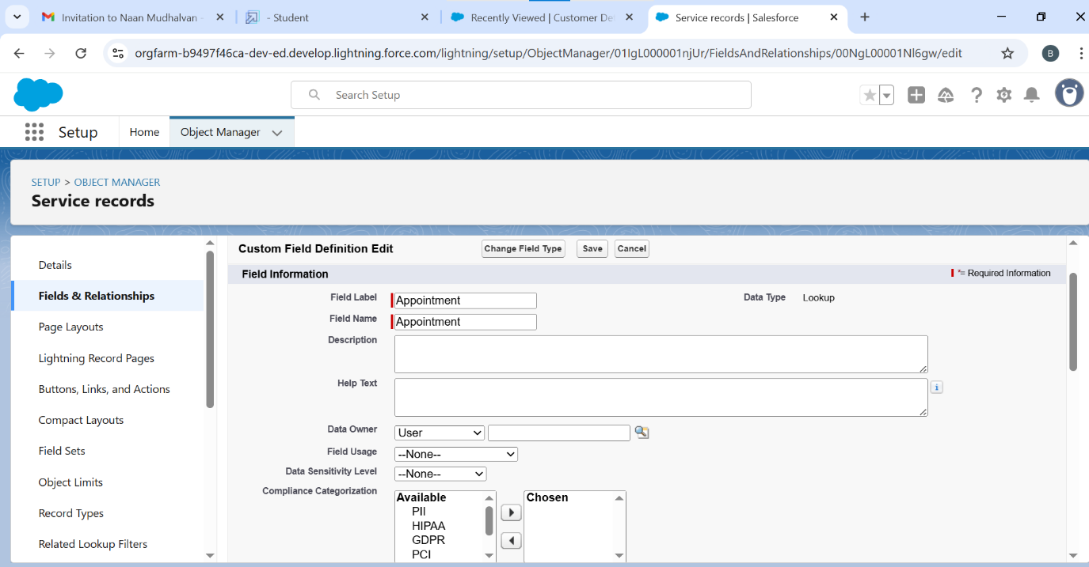

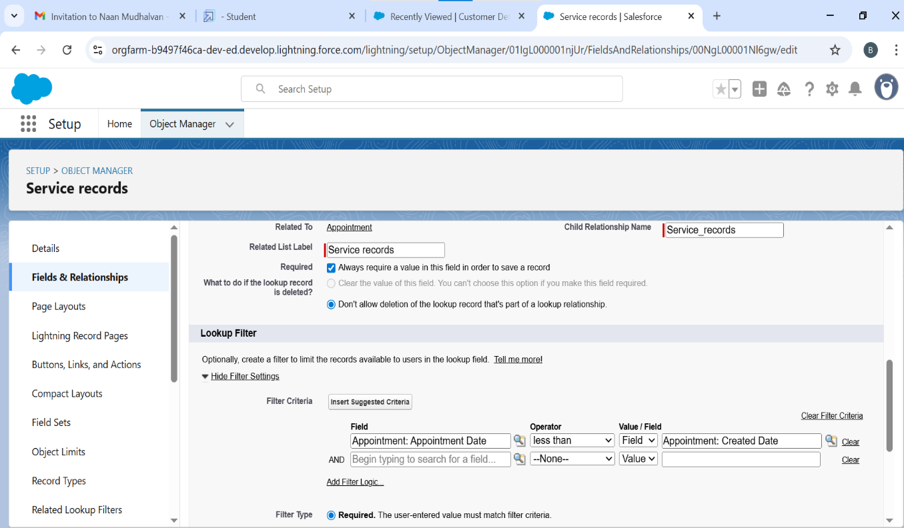

* *Built the other fields for Date fields, Currency fields, Text fields, Picklist fields, and formula field in service record fields*

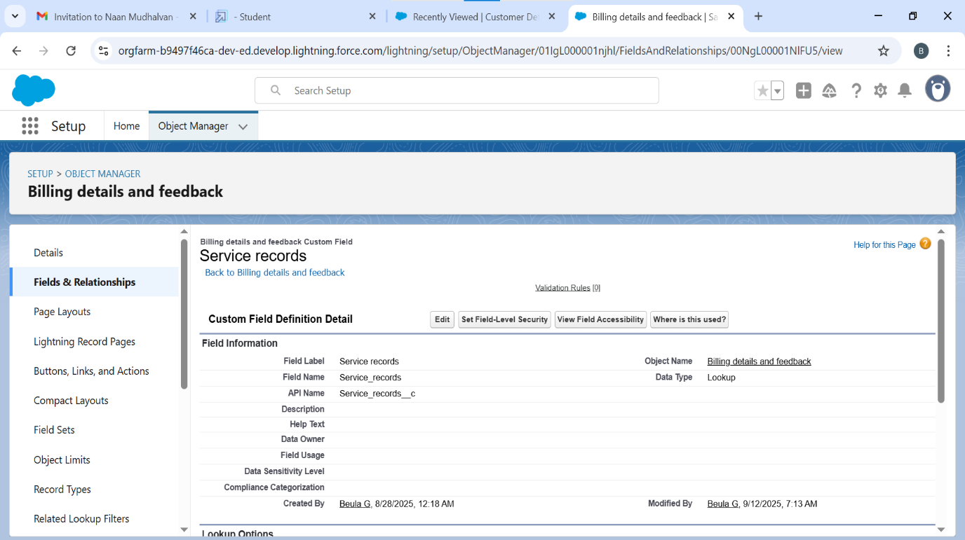

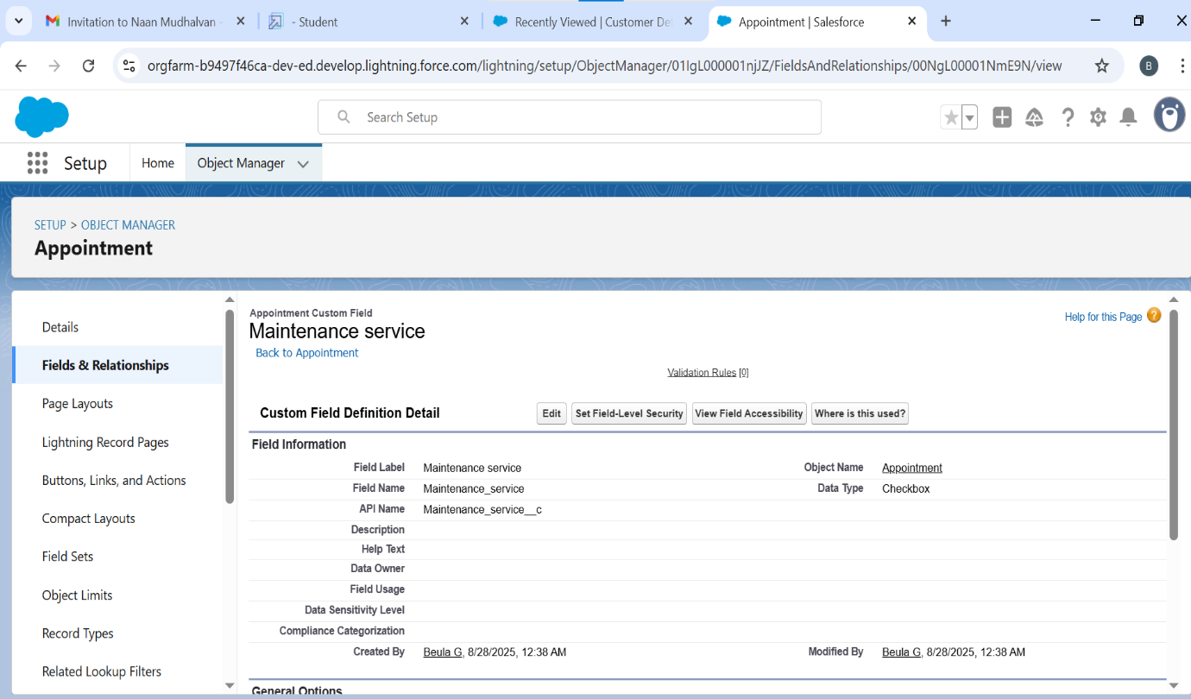

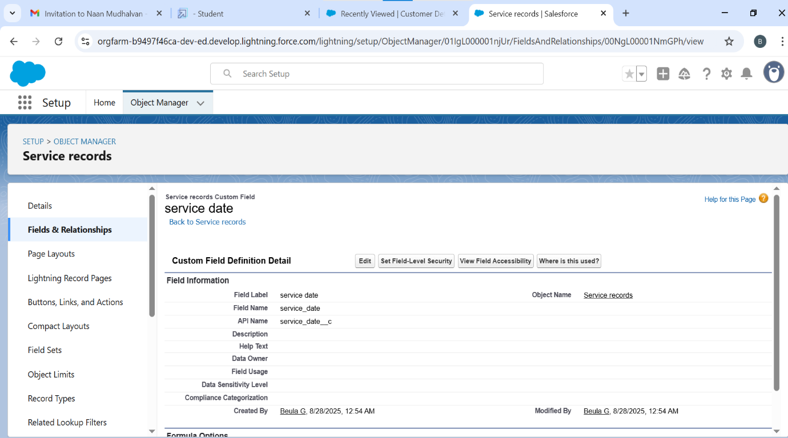

* *To create a validation rule to an appointment object and Billing details and feedback*

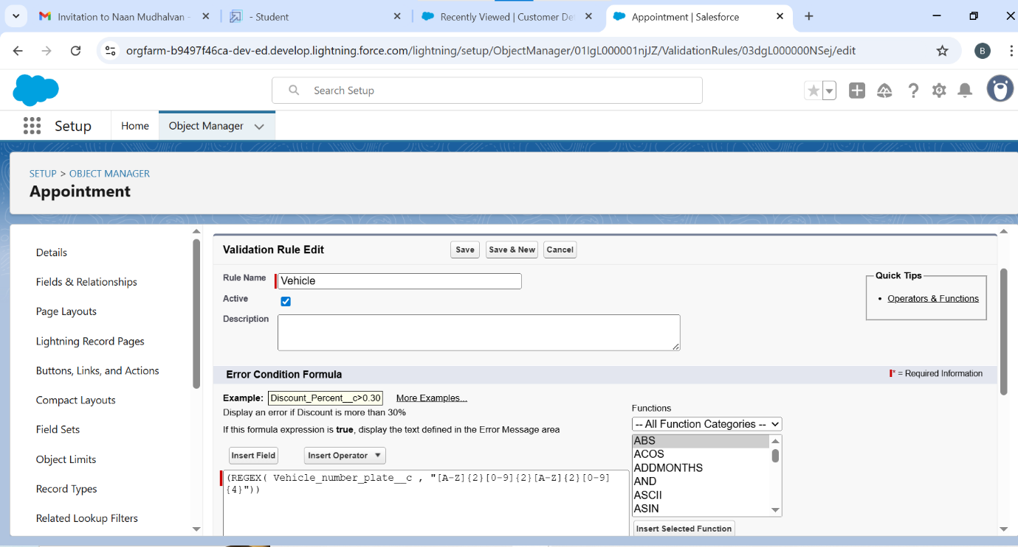

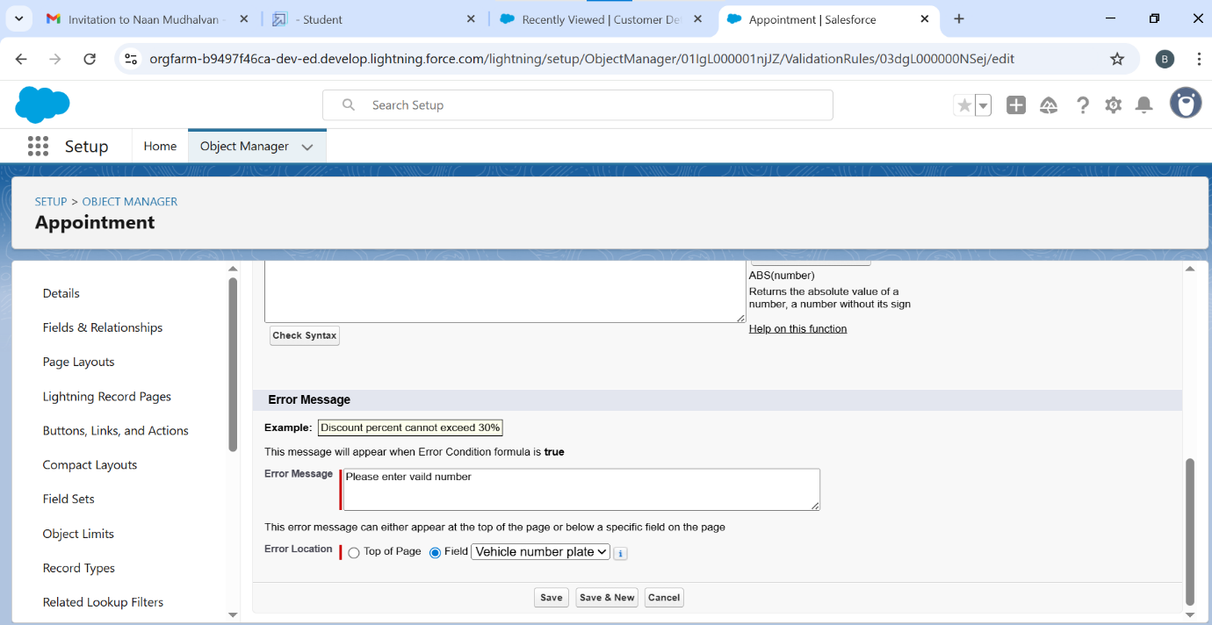

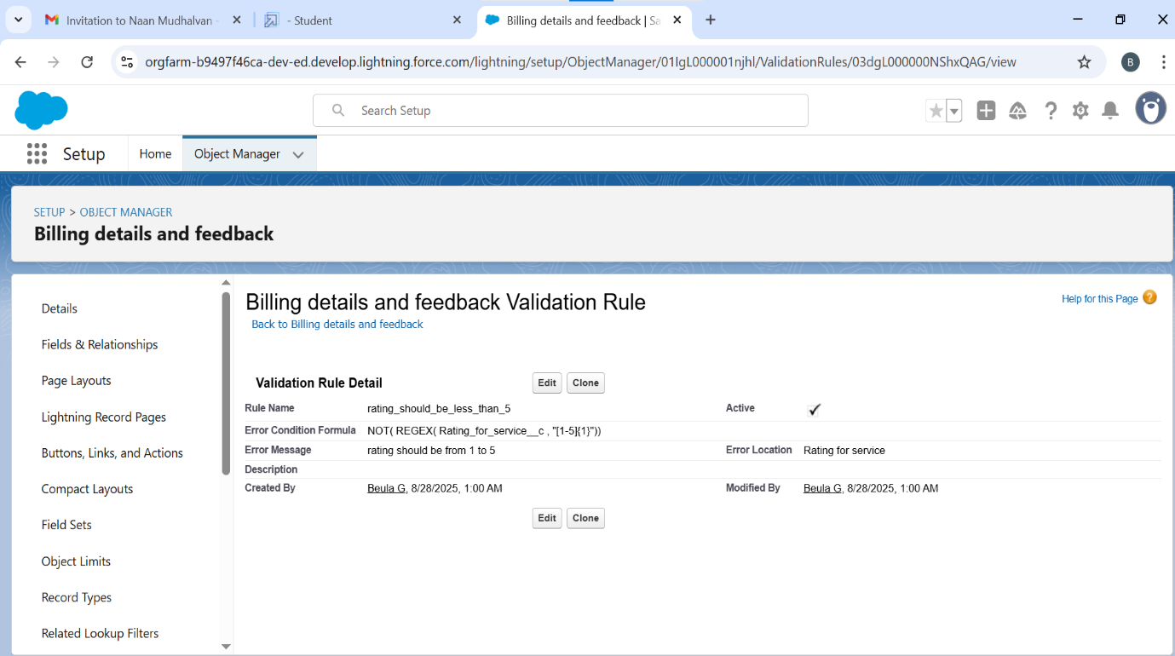

* *To create matching rule and duplicate rule to an customer object details*

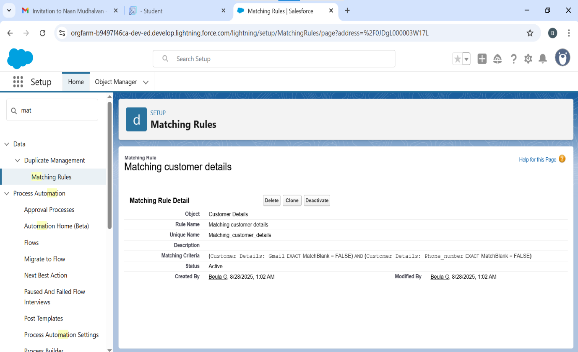

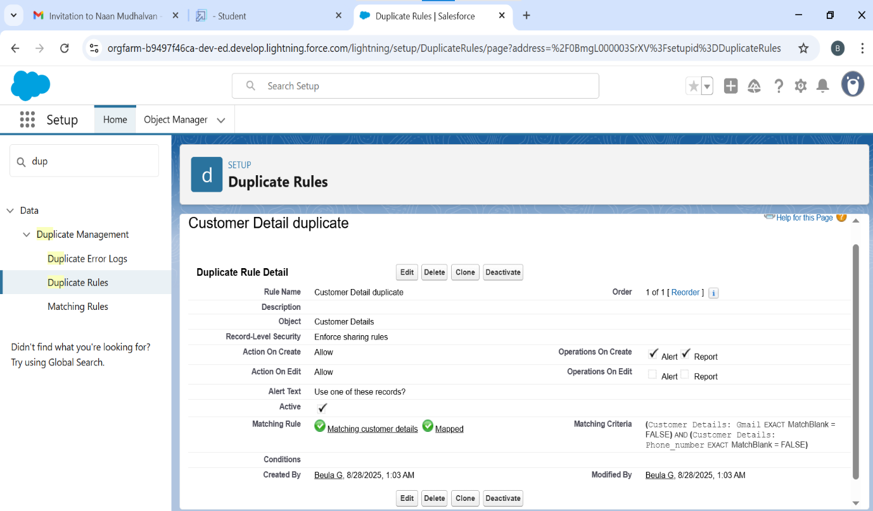

* *Profiles are configured to define user access and permission*

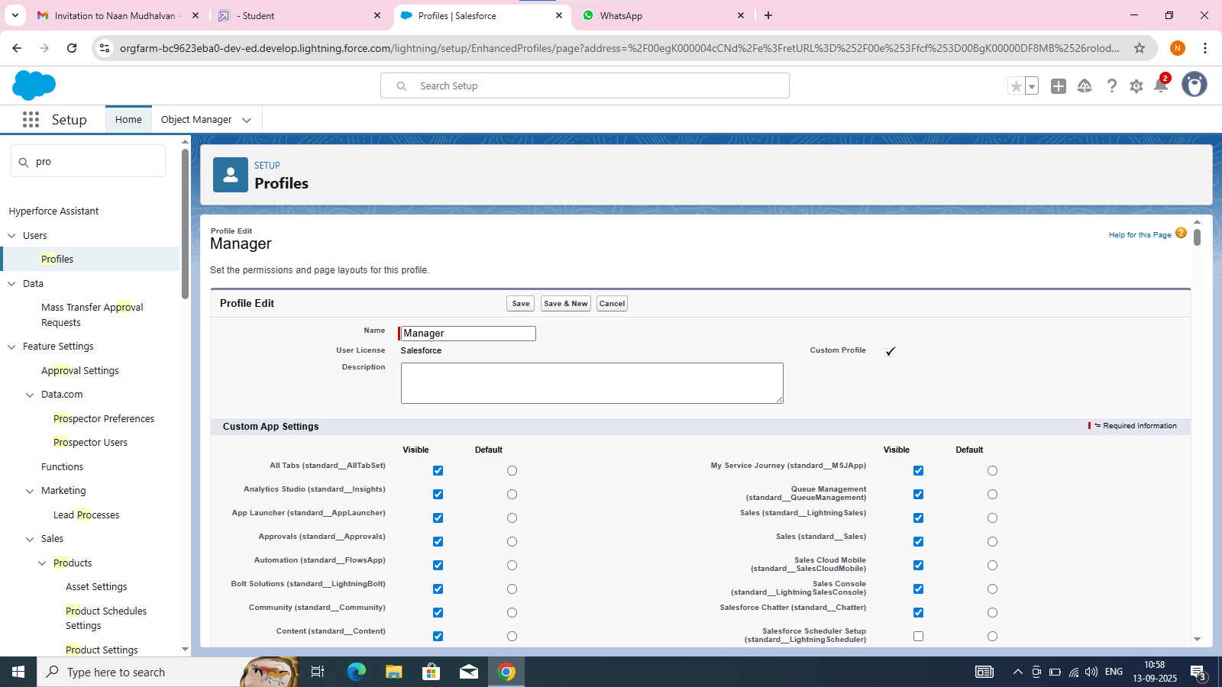

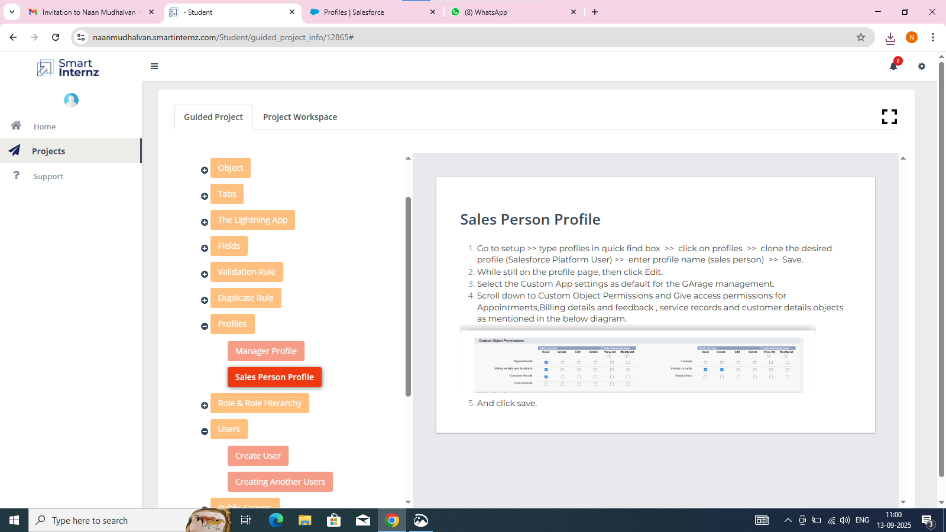

* *Role and role hierarchies to control data visibility*

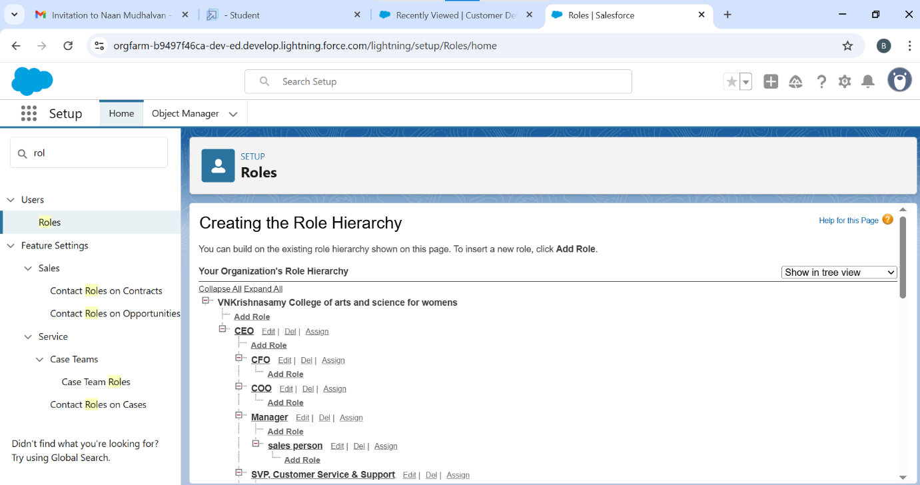

* *Users to the system so multiple people can log in and use the application*

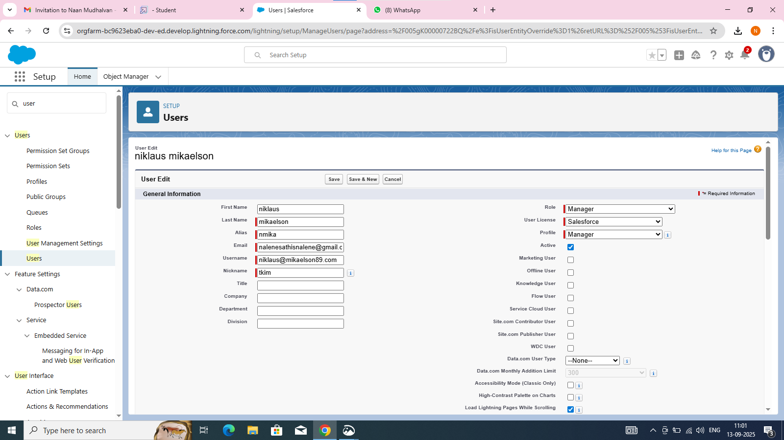

* *Public groups to easily manage sharing settings*

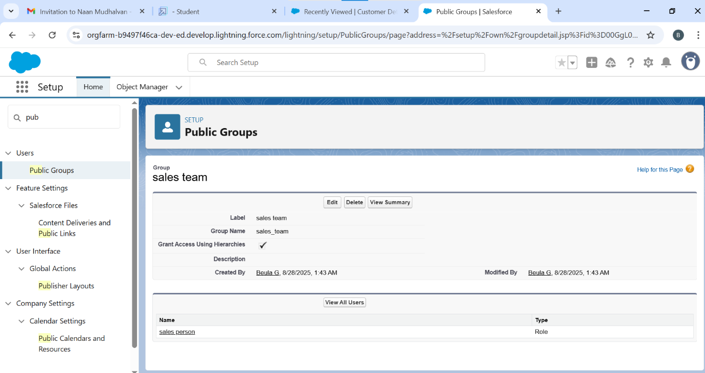

* *Creating sharing settings*

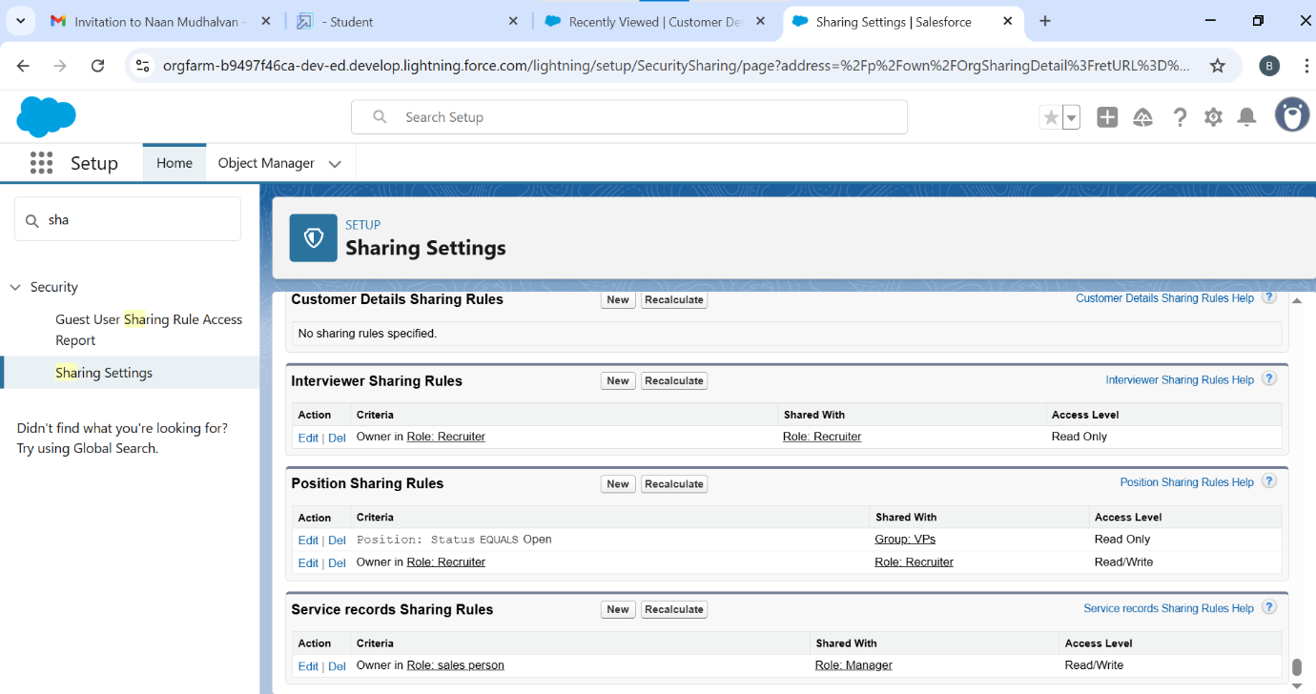

* *Built flows to automate business processes*

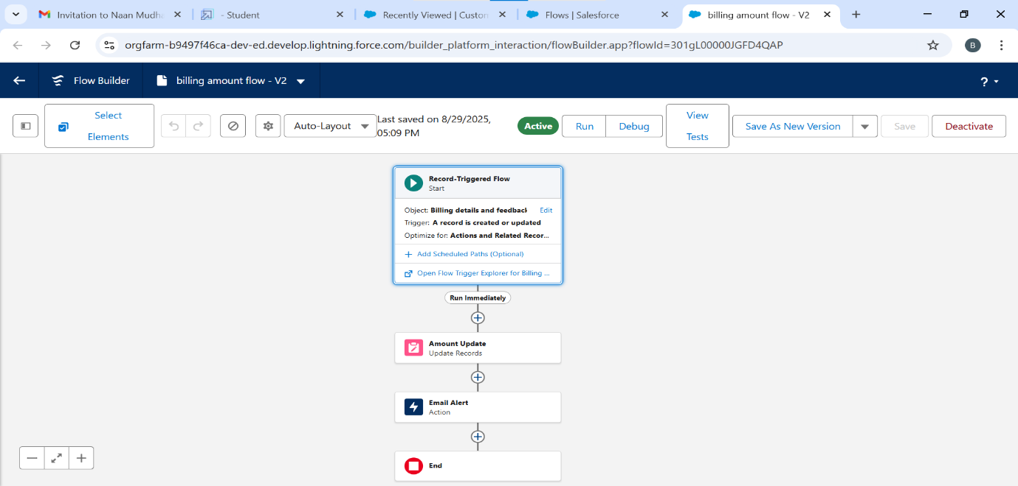

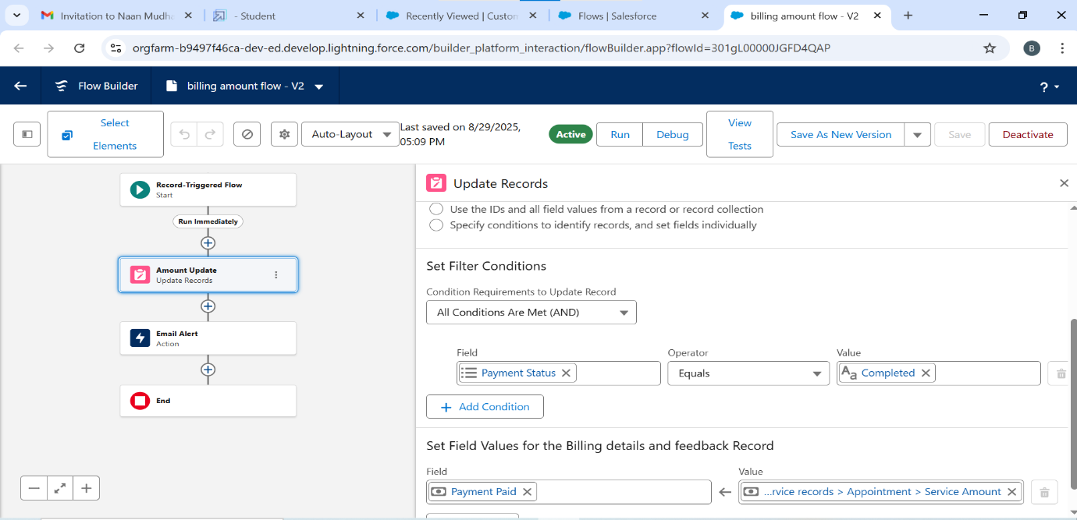

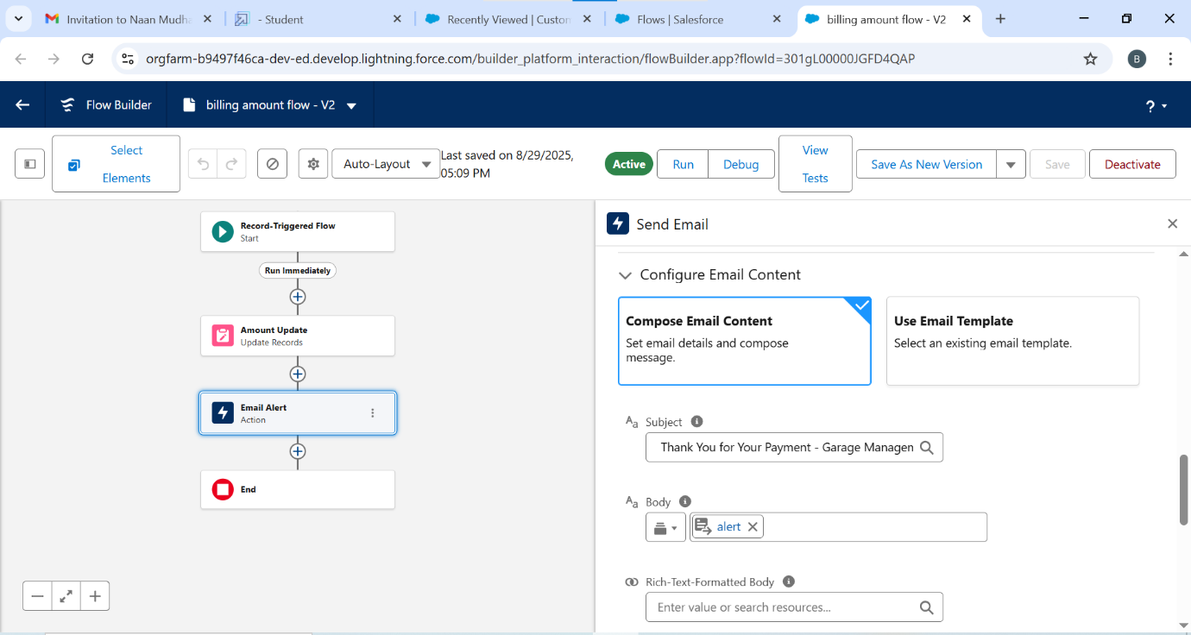

* *Apex trigger and apex handler*

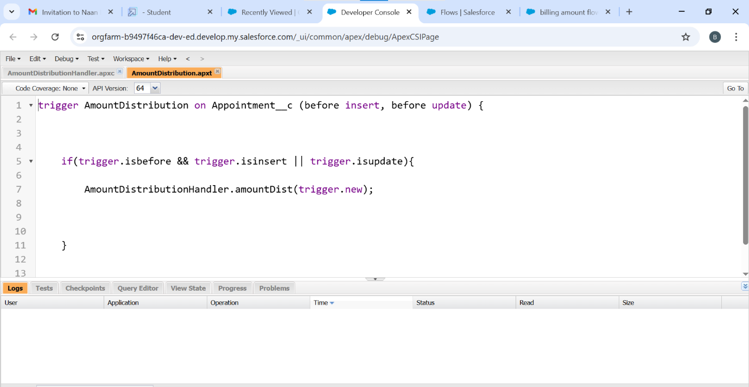

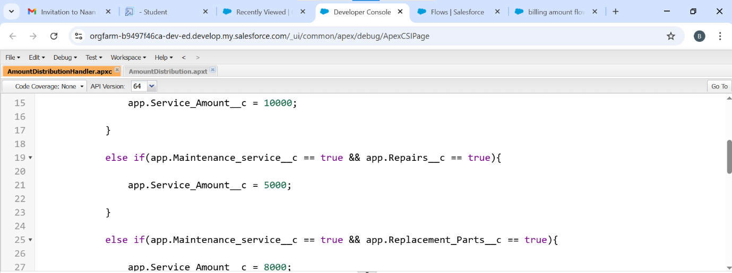

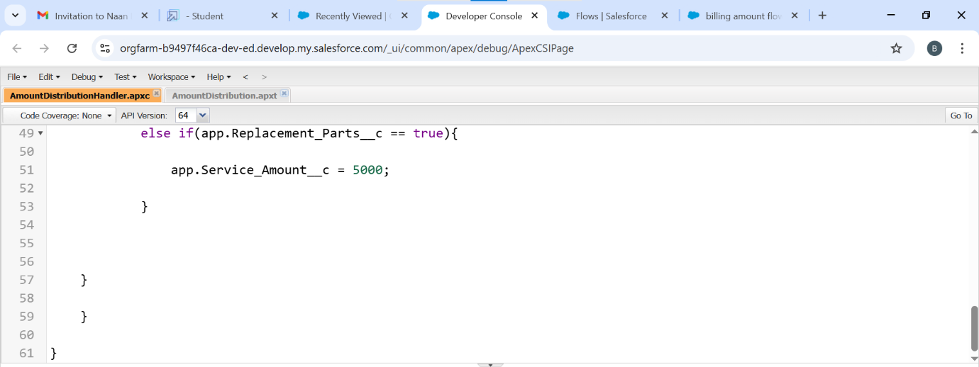

* *Create report and report types*

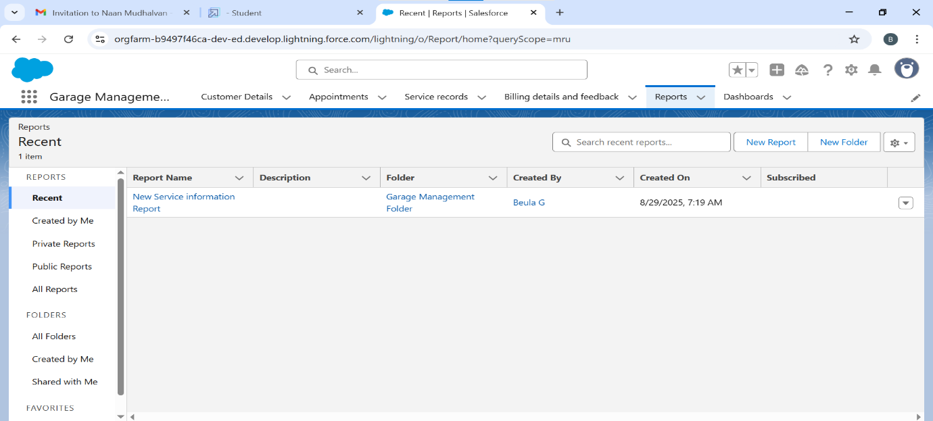

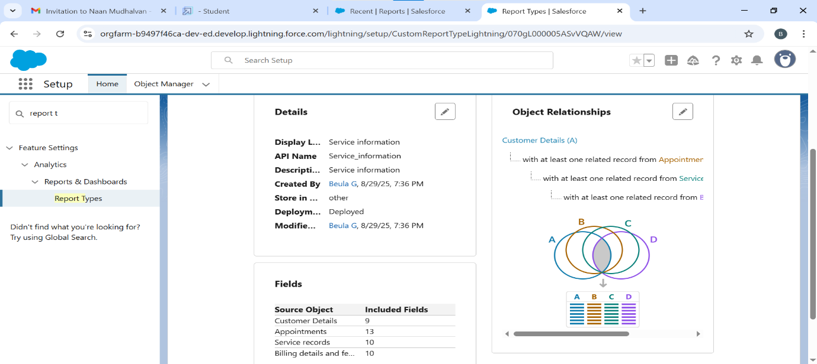

* *Create dashboard*

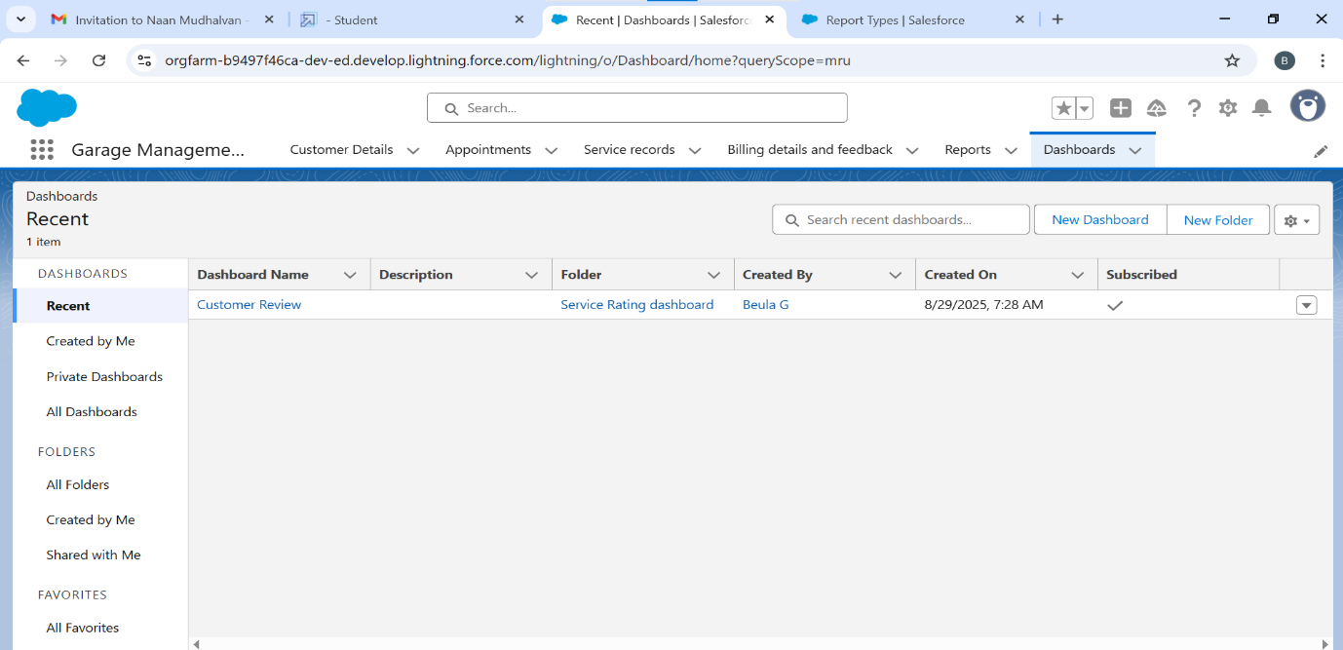

* *Creating records*

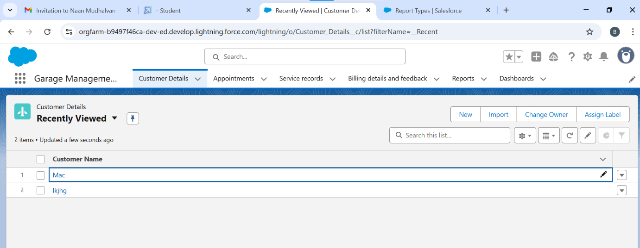

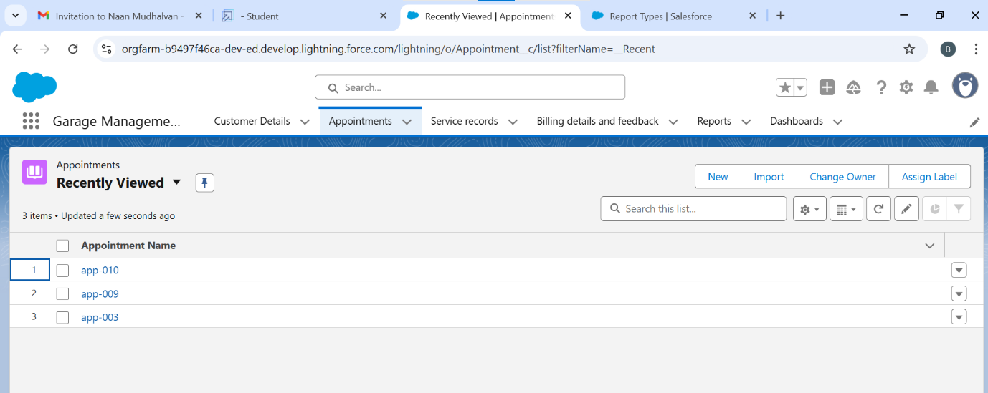

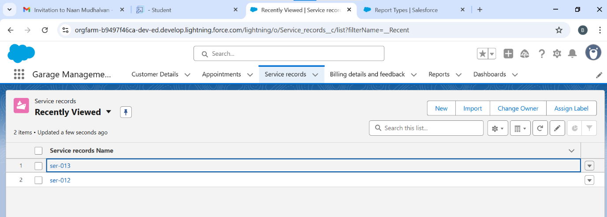

**PERFORMANCE TESTING**

* *Validation by entering duplicate value*

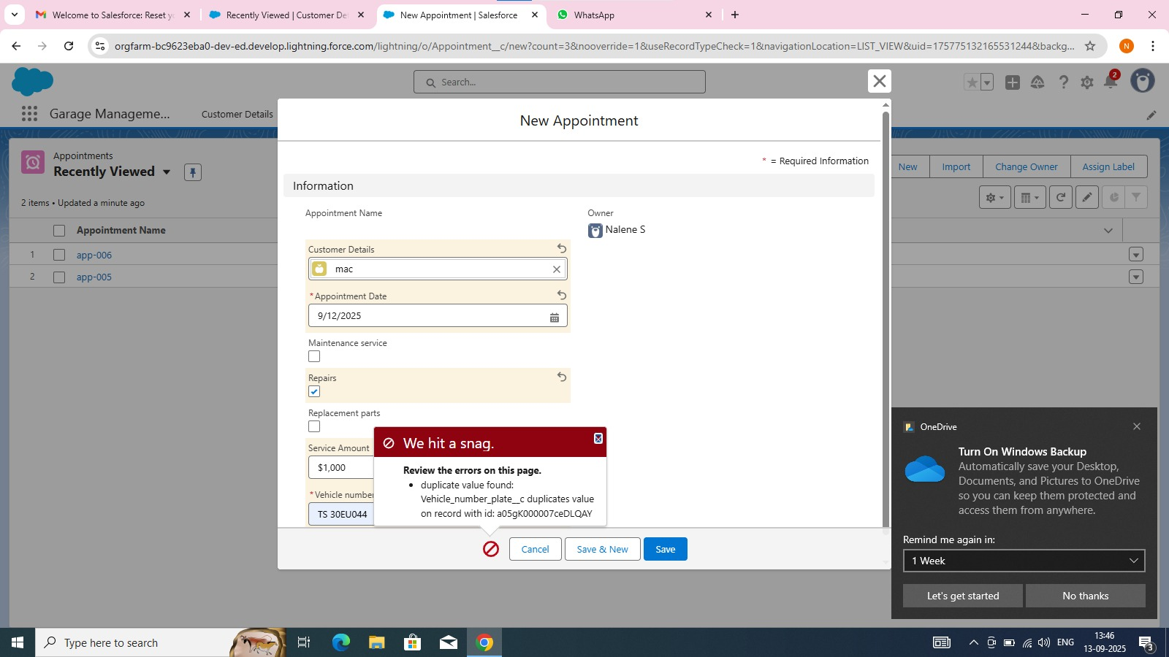

* *Test flows by entering wrong field*

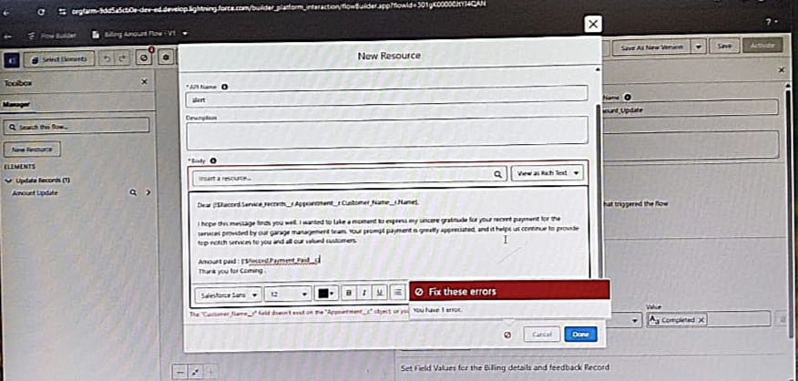

**CONCLUSION**

*The Garage Management System built on Salesforce streamlines every aspect of garage operations from customer and vehicle management to appointment scheduling, inventory tracking, billing, and reporting.*

**APPENDIX**

* **Source code:** *Provided in Apex classes and T*riggers

**AmountDistributionHandler.apxt:**

public class AmountDistributionHandler {

    public static void amountDist(list<Appointment__c> listApp){

        list<Service_records__c> serList = new list <Service_records__c>();

        for(Appointment__c app : listApp){

            if(app.Maintenance_service__c == true && app.Repairs__c == true && app.Replacement_Parts__c == true){

                app.Service_Amount__c = 10000;

            }

            else if(app.Maintenance_service__c == true && app.Repairs__c == true){

                app.Service_Amount__c = 5000;

            }

            else if(app.Maintenance_service__c == true && app.Replacement_Parts__c == true){

                app.Service_Amount__c = 8000;

            }

            else if(app.Repairs__c == true && app.Replacement_Parts__c == true){

                app.Service_Amount__c = 7000;

            }

            else if(app.Maintenance_service__c == true){

                app.Service_Amount__c = 2000;

            }

            else if(app.Repairs__c == true){

                app.Service_Amount__c = 3000;

            }

            else if(app.Replacement_Parts__c == true){

                app.Service_Amount__c = 5000;

            }

    }

    }

}

AmountDistribution.apxt:

trigger AmountDistribution on Appointment__c (before insert, before update) {

    if(trigger.isbefore && trigger.isinsert || trigger.isupdate){

        AmountDistributionHandler.amountDist(trigger.new);

    }

}